**Social Media Analytics Experiment 7**

**Aim:** PowerBi data visualisation

**Output:**

1. Car Dataset

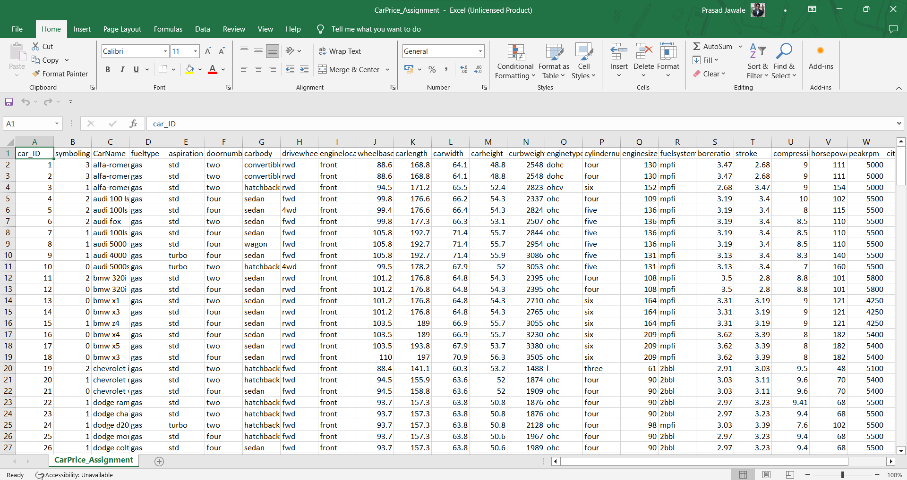

2. PowerBI

